When you first open up this asset, you just need to run the game scene NewScene and then press play.

Concept of Game:
This game is a similar adaption to the famously popular “Cookie Clicker”. The idea is simple. Click the button to pick “Bananas”, When you have enough bananas you can use those bananas to buy an “Auto Picker” Which will pick 0.1 bananas for you every second automatically, As you can probably guess you can keep buying more and more until you are generating billions of bananas per second. We have included 11 upgrades and 11 “Buildings” for you to begin with, but all code has been made with scalability in mind, So you can add inifinite numbers of Upgrades and buidings and the game will scale with ease.

Scripts
BananasPerSec.cs
In your game screen you will need a spot to display the “Bananas per second” you need to drag the script onto that display and then tell the script which text to display, which click file it wants and then drag in each “Building” that you have. So that it can correctly calculate the bananas per second.

Click.cs
This is where the click button get's it's info from and where the bananas value is stored. All you need to do is tell it where you want to display the bananas per click and the total banana count. Nice and simple. Check the script for comments.

currencyConverter.cs
The currency convertor is an invisible object you place into the scene which you can pass values to and it returns the word equivalent. So instead of having 1,000,000 bananas it will return 1.0 Mil bananas. Very handy, just check the file to see how it works and set your own custom terms.

FBHolder.cs
This is the Script that comes with the Facebook plugin, In my scene I have made a simple login with facebook button that you click and it will prompt the user to login with their facebook info. Then it will display there name and their profile pic. This is a great starting point for you to implement scoring and allows people to see their friends scores. All you need to do is drag in the UI items that is where you wil display the profile pic and name, and also where it will display the login button when the user is not already logged in. Be aware in the scene I have hidden the logged in box , to display it you just need to tick the box in the top of the inspector. (You need to replace my facebook app ID with your own, Check the facebook documention for implementation)

ItemManager.cs

This sets most details to public and allows you to set the values from the inspector, this means you can just duplicate the current Items and change the information in the inspector as seen below. Check the comments to see what each function does. It also saves every time you purchase another item, That way Playerprefs is always up to date.

UpgradeManager.cs
This sets most details to public and allows you to set the values from the inspector, this means you can just duplicate the current upgrades and change the information in the inspector. Check the comments to see what each function does. Also Same as ItemManager each time you purchase an upgrade, The count is stored in Playerprefs.

How to add more “Buildings” or “Upgrades”?
Building are in the right panel, They are “automated banana generators!” or “ABG” for short. Upgrades are on the left.
Buildings generate x amount of bananas per second and Upgrades increase the amount of “Bananas Per Click” They have been made with expanding and customizing in mind,
To add a new upgrade or building all you need to do is Duplicate one of the existing ones and set the parameters in the “Inspector”(see below).
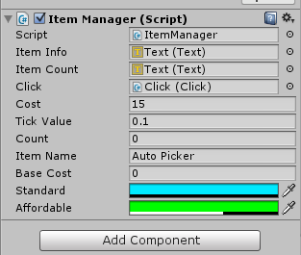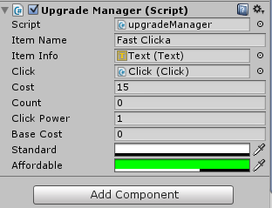
In the inspector each Building has the Item Manager script attached. Upgrades are done in the exact same way, but instead of a tick value they have a “Click Power” which states how much it increases your click power by each upgrade. (These are set high as it helps with testing functionality. You would probably want to reduce their power before releasing a game.)

This allows you to set the Cost, the amount it ticks for each second, the “Count” which is how many you have and it's name. Also you need to drag in a few “Text boxes” to tell the Item Manager where to display.

If you double click the Script “item Manager” you can see the code.

I have gone though and commented as much as I can, Please let me know if you want me to comment more,

I will be online a lot so if anyone has any issues please email me on mike@mpwebdesign.com.au and I will get back to you asap.

Or you can go to my Facebook https://www.facebook.com/MPGameDesign and send me a message from there.

It means a lot if you can go to the Unity store and give me a review, It’s the only real way to show other people that this asset is not to be missed.

http://goo.gl/lmu0LP

